2022 Golf Outing Packet

Are you in charge of your next golf outing?

If you are looking for a fun course to host your next company outing, fundraiser or league outing The Falls is the place to book your event! We are here to provide the quality service and worry free event that will give everyone in your party the “WOW” experience they are looking for. We are here to make this event the most memorable experience that your group will never forget while making it a day everyone will be talking about for years to come.

The following pages will help you put together a complete package for your particular occasion and to answer any questions you might have about running a golf event.

Call The Falls at Barber Creek at 616-675-7345 or email us outings@thefallsatbc.com to book your next golf outing!
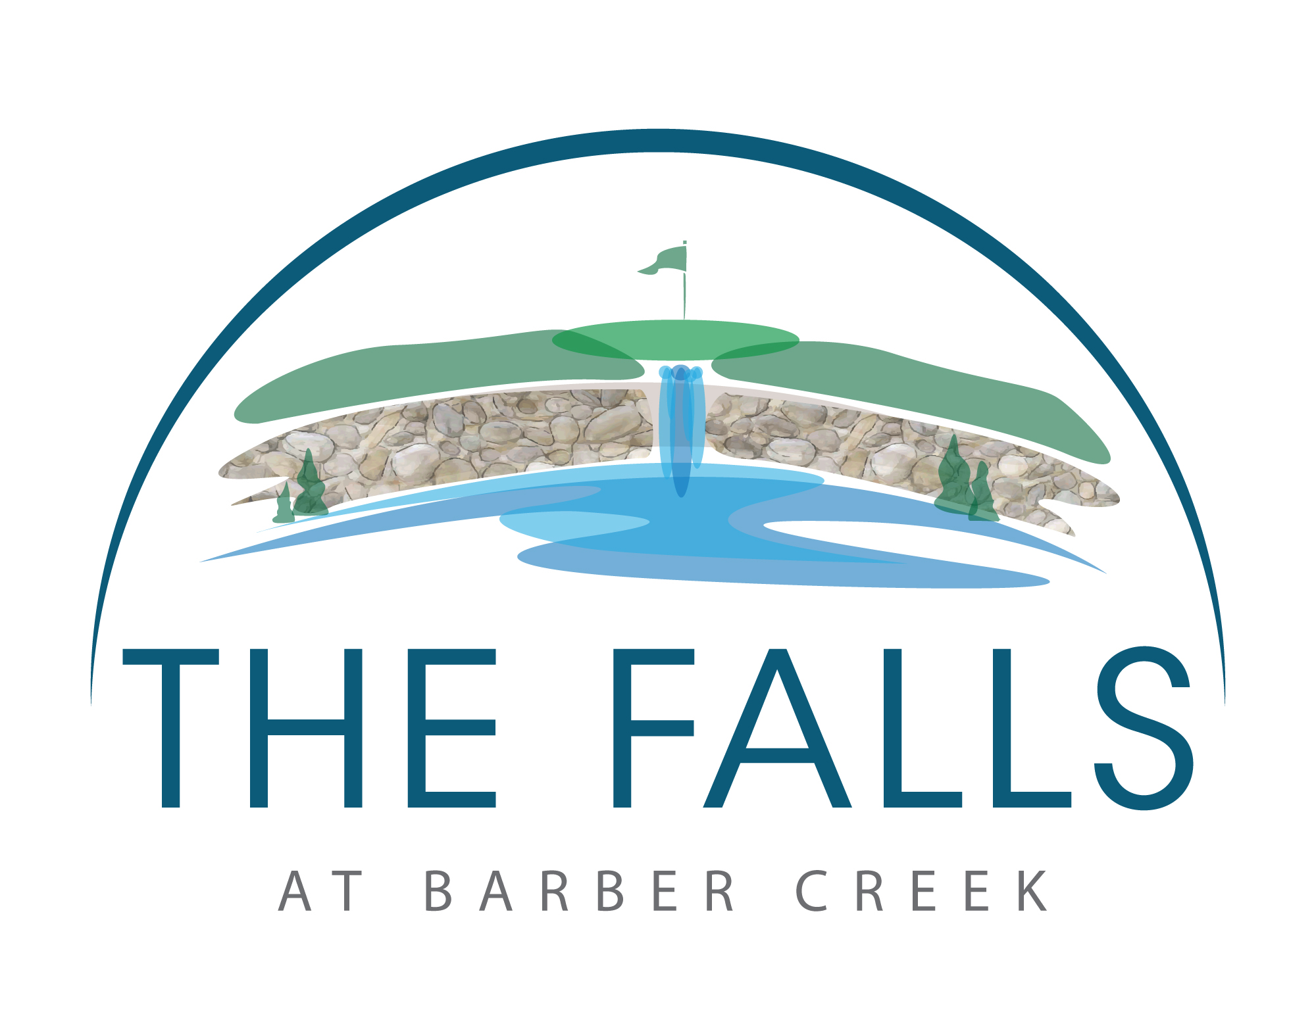

2022 Golf Outing Packages

All packages are priced per person and include 18 holes of golf with golf car, food, special packages and pavilion to host event. Our team members will provide and place cart signs, scorecards with labels, welcome letters with any specific events/rules, alpha sheets with staff directing guests to appropriate golf cars, scoring sheets and proximity markers.

Our pricing is competitive and we can customize your event to meet your groups’ needs.

Steak Package
Monday – Friday $55
Saturday & Sunday $60

Chicken Package
Monday – Friday $52
Saturday & Sunday $57

Burger Package
Monday – Friday $52
Saturday & Sunday $55

Pulled Pork Package
Monday – Friday $50
Saturday & Sunday $55

Pick Two Package
Brat – Hot Dogs - Chicken Breast – Pulled Pork – Burger
Monday – Friday $52
Saturday & Sunday $57

All above are served with your choice of two sides.

Side choices:
Tossed Salad, Potato Salad, Cheesy Potatoes, Au Gratin Potatoes, Baked Beans, Green Beans, Macaroni Salad, Pasta Salad, Chips, Coleslaw, Rolls, Garlic Bread.

Box Lunch Package
Lunch includes a Grinder, condiments, chips, cookie and bottled water
Monday – Friday $52
Saturday & Sunday $55

All menu options include sales tax and service fee. A guaranteed guest count is required 10 days prior to event. All meals are served buffet style. All beverages must be purchased from clubhouse.

Golf Outing Package NO FOOD
Monday – Friday $40
Saturday & Sunday $45

Birdie Package
Golf Clinic 30 Min – 9 Holes
Monday – Friday $50
Saturday & Sunday $60

Eagle Package
Golf Clinic 30 Min – 18 Holes
Monday – Friday $70
Saturday & Sunday $80

Albatross Package
Golf Clinic 1 Hour – 9 Holes
Monday – Friday $70
Saturday & Sunday $80

Ace Package
Golf Clinic 1 Hour – 18 Holes
Monday – Friday $90
Saturday & Sunday $110

Look at the menu prices if you want to add a meal after round.

Add Hole-in-One Package - $200
$5,000 for hole in one

Fundraiser Package – $250
$5,000 for hole in one
Hit-the-boat Challenge

Beat the Pro Package-$100

Hit-the-boat -$100
Includes mat and balls

Tee Gifts Package – Price is based on how many participants and options
- Each player receives a sleeve of golf balls
- Customizable hats
- Tees & water stocked in golf cars

If you would like to just rent our pavilion for your fundraiser the cost will be $500.

Outing convenience fee is subject to management discretion.

2022 Outing Menu Buffets Meal Only
Steak Dinner* | $15
Chicken Dinner | $12
Burger Dinner* | $10
Pulled Pork Dinner | $10
Pick Two Dinner | $12
Brat – Hot Dogs - Chicken Breast – Pulled Pork – Burger
All above are served with your choice of two sides.

Side Choices
Tossed Salad, Potato Salad, Cheesy Potatoes, Au Gratin Potatoes, Baked Beans, Green Beans, Macaroni Salad, Pasta Salad, Chips, Coleslaw, Rolls, Garlic Bread.

Box Lunch | $10
Lunch includes a Grinder, condiments, chips, cookie and bottled water.
*This item is served raw or undercooked, or contains (or may contain) raw or undercooked ingredients.
Consuming raw or undercooked meats, poultry, seafood, shellfish or eggs may increase your RISK of foodborne illness.
All menu options include sales tax and service fee. A guaranteed guest count is required 10 days prior to event. All meals are served buffet style. All beverages must be purchased from clubhouse.

2022 Golf Outing Policies and Procedures

All packages include a shotgun start, crossover start, or straight tee times, depending on available starting times for the date you have chosen. Please read through the following policies and if you have any questions, please ask our outing director to clarify.

1. We require at least 16 people for outing packages that include food from our main menu. All guests must play in foursomes and golf cars are required. If there are an odd number of players, two groups may have less than four players.

2. 30 Days prior to the event a rough estimate of the number of guests is required.

3. 15 Days prior to the event payment is required for the number of guests attending. (Ex: 60 guests times package price = payment due.) No refunds are given for no-shows.

4. 3 Days prior to the event is Drop and Add Day. You may increase or decrease the number of guests by 10%. No refunds will be given for no-shows after the 3 days notice. Payment for additional guests is due the day of the event.

5. 2 Days prior to the event you must supply us with a players pairings list by foursomes and their order of tee times.

6. A signed agreement must be returned to us within 10 days of being sent to you. The signed agreement acknowledges the terms of the outing and agreement with the policies regarding procedures, weather and sponsorship activities. Menu choice and sides must be completed at this time.

7. The State of Michigan Liquor Control Commission requires that all alcoholic beverages consumed on our premises must be purchased from The Falls at Barber Creek. It is the responsibility of the outing organizer to inform the outing participants of the Liquor Control Law; outing participants that violate the Liquor Control Law will be asked to leave the premises and no refund will be issued. All bags are subject to search. Minors will not be allowed to consume alcoholic beverages on our premises at any time. Sponsors may not distribute or redistribute any alcoholic beverages.

8. Pace of play: All players are expected to play in a timely manner. Our pace of play is a maximum of 4 hours and 30 minutes. The position of all groups on the golf course should be directly behind the group in front of them.

9. Golf car policy: We expect golfers to use golf cars in a safe manner and abide by all directions, both written and verbal. Liability for damages to the premises or our golf cars will be charged to the person or company making the golf outing reservation.

10. With the exception of special cakes, all food must be purchased from The Falls at Barber Creek.

11. Sales tax and room/service charges are included in the price of the meals. Gratuity for beverage service is not included and is up to the discretion of the customers.

12. Outings played Monday through Thursday that use a straight tee time start or a crossover start must complete their tee-off by 12:52 PM and finish turning by 3:15 PM.

13. Shotgun starts are available for any size groups with conditions; The Falls at Barber Creek will decide how many holes and the placement of teams on the holes. Exclusivity can be arranged for an additional fee; That fee is based on the difference between group participants and 144-players. Sponsorship Activities Sponsorships are the lifeblood of many golf outings. We are committed to helping you in having a successful event for your golfers while providing sponsorship opportunities for your supporters.

14. We will supply tables and chairs for the pavilion.

15. Cart usage by sponsors: All extra carts are provided at our option. Sponsors may use the cart to drive between the hole they are sponsoring and the clubhouse. No more than two adults may be on the cart at one time. At the sponsor holes, the cart must be parked off the cart paths in the long grass, not on the tee surface or green surface. Carts are not allowed in the parking lot unless driven by our staff. All items that must be taken to the holes can be dropped at the bag drop area where our staff will help to accommodate the sponsors. Sponsors should arrive early and drop off their items at the bag drop so our staff can help them get organized and out to their sponsor area.

16. Cancellation Due to Inclement Weather. No refunds will be given based on weather forecasts. If you have an event planned, plan on being at the golf course prior to the event’s start time. All weather related issues would be discussed and resolved between our outing director and you, the outing representative. This includes but is not limited to delays in play, suspension of play, restarting of play, rain checks, cancellations and rescheduling. Our outing director will inform you, the outing representative, as soon as possible if the course is going to be closed due to weather related issues. However, in most cases, that decision cannot be made until the planned start time of the event. A delay in the start of play or a suspension in play will occur when severe weather is in the area. The length of the delay or suspension will be determined by the weather and course conditions. The Falls at Barber Creek holds the right to delay the start or suspend play of an event up to an hour. In the event of a suspension of play, The Falls at Barber Creek reserves the right to reduce the amount of holes in order to meet other scheduled commitments and make adjustments to the fee. After that time, an event can be canceled or, if possible, rescheduled. In the event play has started and the course becomes unplayable, if rescheduling the event is not possible, all players would be entitled to a rain check. All rain check transactions will be handled between our outing director and you, the outing representative. If a food program was scheduled, the outing representative could either schedule the food program for a time later in the day, which would allow our staff enough time to prepare the meal.

2022 Golf Outing Agreement

The outing representative ______________________________ agrees with the outing director _________________________________ to select package__________________________ for the price of ____________ per player on the date/time of __________________________________ . The outing representative and director agree to all of The Falls at Barber Creek’s policies and procedures.

Thank you for choosing The Falls at Barber Creek as the host of your golf outing.

Outing Representative Outing Director

__________________________________ ________________________________
Signature Signature

__________________________________ _________________________________
Printed Name Printed Name

Date_________________ Date_________________

Comments and Details of Event. (Example. Food to be prepared, proximities, hole-in-one package, fundraiser sponsorship details.)

________________________________________________________________________________________________

________________________________________________________________________________________________

________________________________________________________________________________________________

________________________________________________________________________________________________

________________________________________________________________________________________________

________________________________________________________________________________________________

________________________________________________________________________________________________

